Day 1 – Practical Session
Course Code: DSA0613
Course: Data Handling and Visualization
1. Visualize Scatter plot for given dataset.
Weight (kg) | Height (cm)
60 | 170
65 | 175
70 | 168
72 | 180
75 | 178

Sample Code:
# Load necessary library
library(ggplot2)
# Create a data frame
weight_height_data <- data.frame(
Weight = c(60, 65, 70, 72, 75),
Height = c(170, 175, 168, 180, 178)
)
# Plot scatter plot
ggplot(weight_height_data, aes(x = Weight, y = Height)) +
geom_point(color = "blue", size = 3) +
labs(title = "Weight vs. Height",
x = "Weight (kg)",
y = "Height (cm)") +
theme_minimal()
OUTPUT:
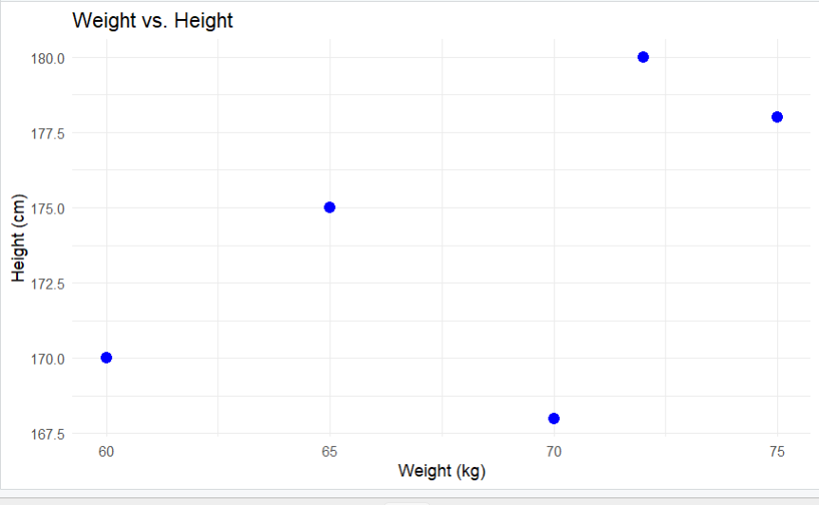
2. Visualize a Line Plot for the Given Population Data
Year | Population (millions)
2010 | 1000
2011 | 1020
2012 | 1040
2013 | 1060
2014 | 1080

# Create a data frame
year_population_data <- data.frame(
Year = 2010:2014,
Population = c(1000, 1020, 1040, 1060, 1080)
)
# Plot line plot
ggplot(year_population_data, aes(x = Year, y = Population)) +
geom_line(color = "green", size = 1) +
geom_point(color = "red", size = 3) +
labs(title = "Year vs. Population",
x = "Year",
y = "Population (millions)") +
theme_minimal()
OUTPUT:
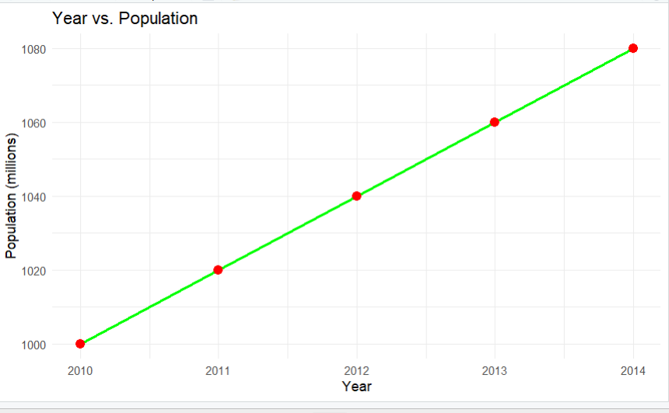

3. Bar Plot
Dataset: Sales by Product
Product | Sales
A | 300
B | 450
C | 500
D | 350
E | 400

# Create a data frame
sales_data <- data.frame(
Product = c("A", "B", "C", "D", "E"),
Sales = c(300, 450, 500, 350, 400)
)
# Plot bar plot
ggplot(sales_data, aes(x = Product, y = Sales, fill = Product)) +
geom_bar(stat = "identity") +
labs(title = "Sales by Product",
x = "Product",
y = "Sales") +
theme_minimal()
OUTPUT:
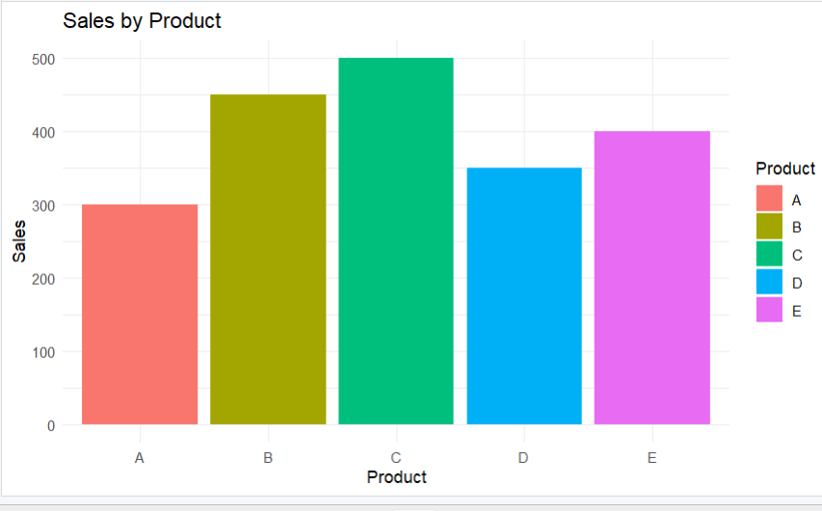
4. Histogram
Dataset: Age Distribution
Age

25

30

35

40

45

50

55

60

65

70

# Create a data frame
age_data <- data.frame(
Age = c(25, 30, 35, 40, 45, 50, 55, 60, 65, 70)
)# Plot histogram
ggplot(age_data, aes(x = Age)) +
geom_histogram(binwidth = 5, fill = "purple", color = "black", alpha = 0.7) +
labs(title = "Age Distribution",
x = "Age",
y = "Frequency") +
theme_minimal()

OUTPUT:
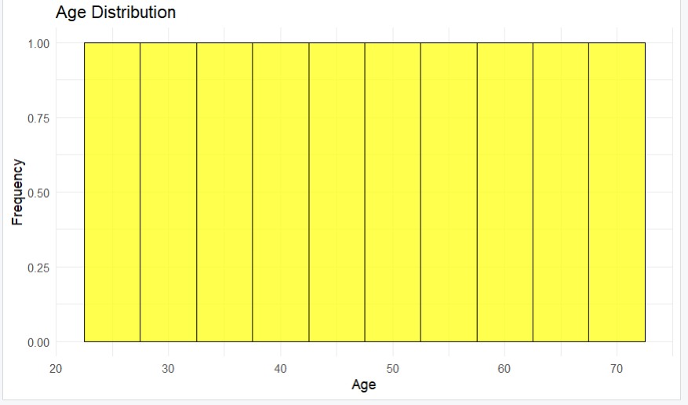

5. Pie Chart
Dataset: Market Share by Company
Company | Market Share
A | 20%
B | 30%
C | 25%
D | 25%

# Create a data frame
market_share_data <- data.frame(
Company = c("A", "B", "C", "D"),
Market_Share = c(20, 30, 25, 25)
)
# Plot pie chart
ggplot(market_share_data, aes(x = "", y = Market_Share, fill = Company)) +
geom_bar(stat = "identity", width = 1) +
coord_polar("y") +
labs(title = "Market Share by Company",
x = NULL,
y = NULL) +
theme_void() +
theme(legend.position = "right")
OUTPUT:
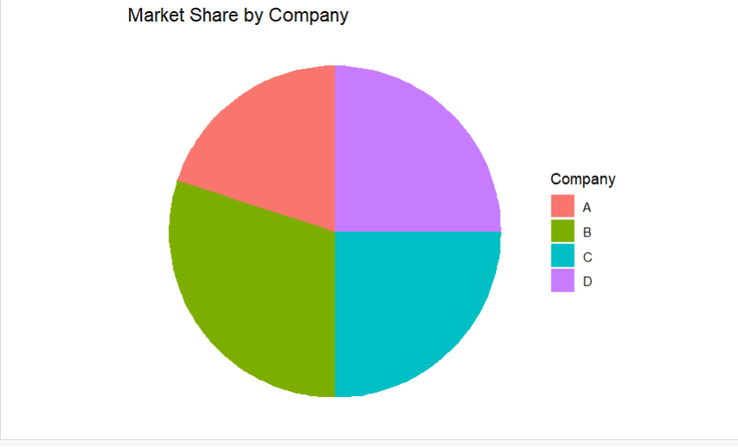

6. Box Plot
Dataset: Exam Scores by Class
Class | Scores
A | 85
A | 90
A | 78
A | 92
B | 88
B | 76
B | 80
B | 84
scores_data <- data.frame(
Class = c("A", "A", "A", "A", "B", "B", "B", "B"),
Scores = c(85, 90, 78, 92, 88, 76, 80, 84)
)
# Plot box plot
ggplot(scores_data, aes(x = Class, y = Scores, fill = Class)) +
geom_boxplot() +
labs(title = "Exam Scores by Class",
x = "Class",
y = "Scores") +
theme_minimal()
OUTPUT:
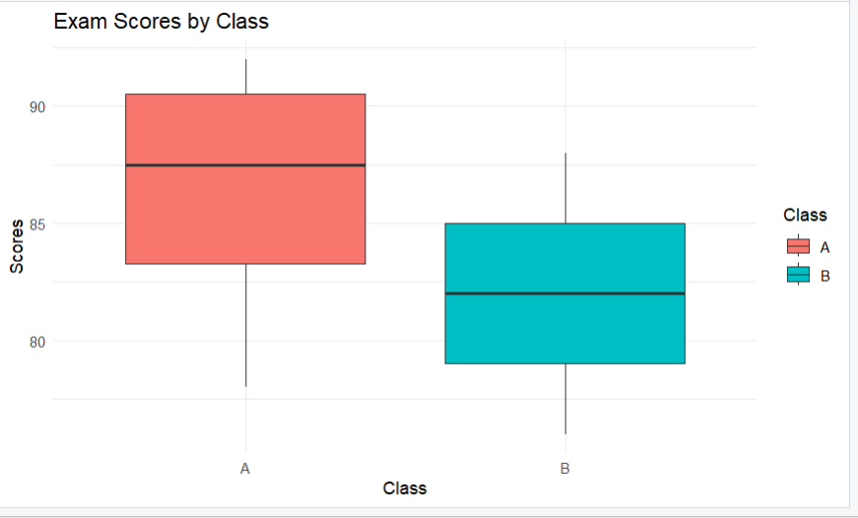
7. Density Plot
Dataset: Weights of Individuals
Weight (kg)

60

65

70

75

80

85

90

95

100

# Create a data frame
weights_data <- data.frame(
Weight = c(60, 65, 70, 75, 80, 85, 90, 95, 100)
)
# Plot density plot
ggplot(weights_data, aes(x = Weight)) +
geom_density(fill = "lightblue") +
labs(title = "Density Plot of Weights",
x = "Weight (kg)",
y = "Density") +
theme_minimal()

OUTPUT:
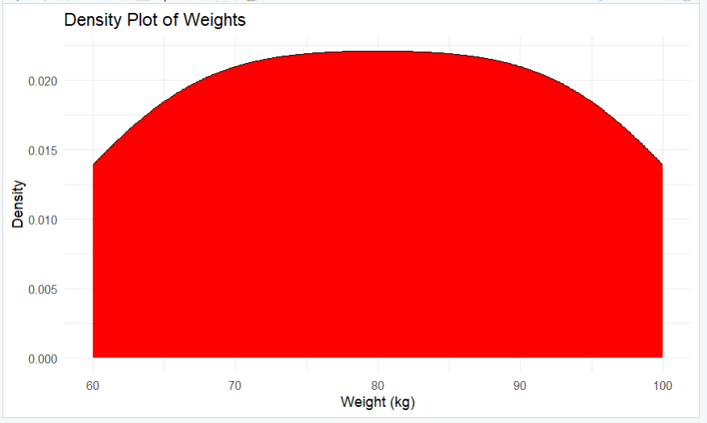

8. Violin Plot
Dataset: Scores by Group
Group | Score
X | 80
X | 85
X | 78
X | 92
Y | 88
Y | 76
Y | 80
Y | 84
# Create a data frame
scores_group_data <- data.frame(
Group = c("X", "X", "X", "X", "Y", "Y", "Y", "Y"),
Score = c(80, 85, 78, 92, 88, 76, 80, 84)
)# Plot violin plot
ggplot(scores_group_data, aes(x = Group, y = Score, fill = Group)) +
geom_violin() +
labs(title = "Scores by Group",
x = "Group",
y = "Score") +
theme_minimal()
OUTPUT:
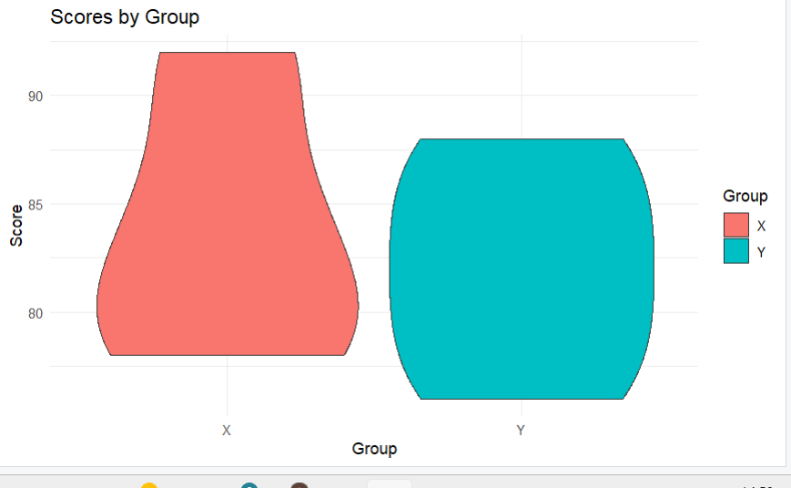
9. Heatmap
Dataset: Monthly Temperatures
Month | City A | City B | City C
Jan | 5 | 10 | 15
Feb | 6 | 11 | 16
Mar | 7 | 12 | 17
Apr | 8 | 13 | 18
May | 9 | 14 | 19
temperature_data <- data.frame(
Month = c("Jan", "Feb", "Mar", "Apr", "May"),
City_A = c(5, 6, 7, 8, 9),
City_B = c(10, 11, 12, 13, 14),
City_C = c(15, 16, 17, 18, 19)
)#Reshape data for heatmap
library(reshape2)
melted_data <- melt(temperature_data, id.vars = "Month")
# Plot heatmap
ggplot(melted_data, aes(x = Month, y = variable, fill = value)) +
geom_tile() +
scale_fill_gradient(low = "white", high = "red") +
labs(title = "Monthly Temperatures",
x = "Month",
y = "City") +
theme_minimal()
OUTPUT:
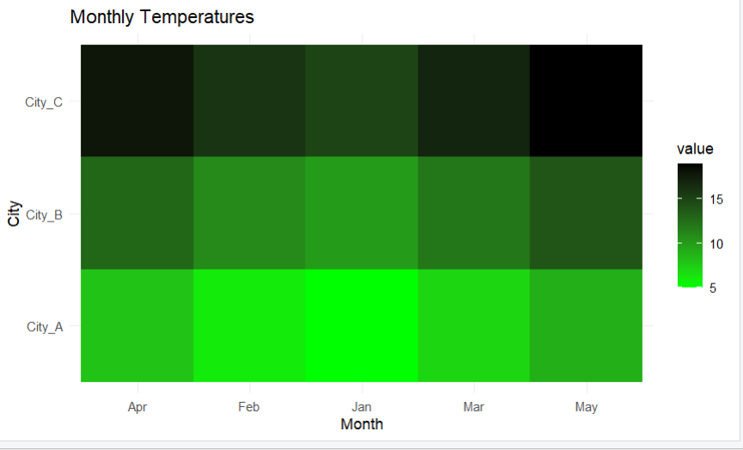

10. Facet Plot
Dataset: Sales by Month and Region
Month | Region | Sales
Jan | East | 200
Jan | West | 150
Feb | East | 220
Feb | West | 170
Mar | East | 210
Mar | West | 160
# Create a data frame
sales_region_data <- data.frame(
Month = c("Jan", "Jan", "Feb", "Feb", "Mar", "Mar"),
Region = c("East", "West", "East", "West", "East", "West"),
Sales = c(200, 150, 220, 170, 210, 160)
)
# Plot facet plot
ggplot(sales_region_data, aes(x = Month, y = Sales, fill = Region)) +
geom_bar(stat = "identity", position = "dodge") +
facet_wrap(~ Region) +
labs(title = "Sales by Month and Region",
x = "Month",
y = "Sales") +
theme_minimal()
OUTPUT:
